**Data exploration seed counting**

Alicia

Wed Feb 17 16:42:22 2016

*\*When counting, considered as developed/mature seeds those that were relatively big and looked fresh and free from mould, etc. Seeds that were very small, looked flat or that were big but fully covered in mould were considered all as “undeveloped” (they won’t contribute to the fitness).*

*\*When more than 1 intact (unpredated-up) or predated (p) fruit was available for a marked plant, values are means (although in most of the cases there was only 1 fruit available).*

*Differences in number and proportion of developed/mature seeds and in seed weight among up and p fruits: Assessed using 30 plant individuals (2 from Högsjön, 2 from Remmene, rest from Tånga) for which I had both an intact and a predated fruit.*

Histograms of number, percentage and mean weight (µg) of developed seeds per fruit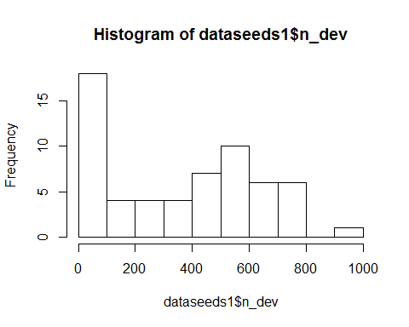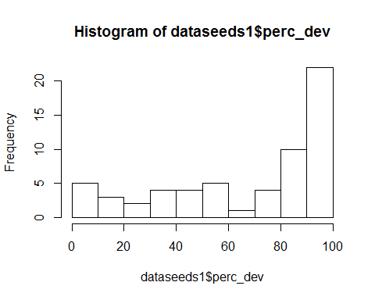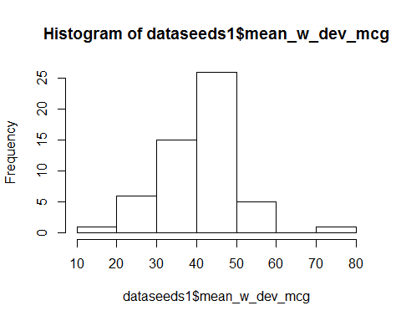

#Does number of developed seeds differ between up and p fruits? 🡪 YES

mod1<-glmer(round(n_dev)~p_up+(1|pl_id)+(1|id),family="poisson",data=dataseeds1)  
summary(mod1)

## Generalized linear mixed model fit by maximum likelihood (Laplace  
## Approximation) [glmerMod]  
## Family: poisson ( log )  
## Formula: round(n_dev) ~ p_up + (1 | pl_id) + (1 | id)  
## Data: dataseeds1  
##   
## AIC BIC logLik deviance df.resid   
## 845.7 854.1 -418.9 837.7 56   
##   
## Scaled residuals:   
## Min 1Q Median 3Q Max   
## -1.36177 -0.00583 0.00515 0.01088 0.04482   
##   
## Random effects:  
## Groups Name Variance Std.Dev.  
## id (Intercept) 1.88170 1.3717   
## pl_id (Intercept) 0.09246 0.3041   
## Number of obs: 60, groups: id, 60; pl_id, 30  
##   
## Fixed effects:  
## Estimate Std. Error z value Pr(>|z|)   
## (Intercept) 4.2544 0.2621 16.234 < 2e-16 ***  
## p_upup 1.8619 0.3584 5.196 2.04e-07 ***  
## ---  
## Signif. codes: 0 '***' 0.001 '**' 0.01 '*' 0.05 '.' 0.1 ' ' 1  
##   
## Correlation of Fixed Effects:  
## (Intr)  
## p_upup -0.698

overdisp.glmer(mod1) #There is not overdispersion! - Model OK

## Residual deviance: 15.174 on 56 degrees of freedom (ratio: 0.271)

#Does proportion of developed seeds differ between up and p fruits? 🡪YES  
mod2<-glmer(prop_dev~p_up+(1|pl_id)+(1|id),family="binomial",data=dataseeds1)  
summary(mod2)

## Generalized linear mixed model fit by maximum likelihood (Laplace  
## Approximation) [glmerMod]  
## Family: binomial ( logit )  
## Formula: prop_dev ~ p_up + (1 | pl_id) + (1 | id)  
## Data: dataseeds1  
##   
## AIC BIC logLik deviance df.resid   
## 723.1 731.5 -357.5 715.1 56   
##   
## Scaled residuals:   
## Min 1Q Median 3Q Max   
## -2.1246 0.0000 0.0144 0.0415 0.1159   
##   
## Random effects:  
## Groups Name Variance Std.Dev.  
## id (Intercept) 0.53909 0.7342   
## pl_id (Intercept) 0.09112 0.3019   
## Number of obs: 60, groups: id, 60; pl_id, 30  
##   
## Fixed effects:  
## Estimate Std. Error z value Pr(>|z|)   
## (Intercept) -0.9197 0.1541 -5.966 2.42e-09 ***  
## p_upup 0.6489 0.1971 3.293 0.000993 ***  
## ---  
## Signif. codes: 0 '***' 0.001 '**' 0.01 '*' 0.05 '.' 0.1 ' ' 1  
##   
## Correlation of Fixed Effects:  
## (Intr)  
## p_upup -0.681

overdisp.glmer(mod2) #There is not overdispersion! - Model OK

## Residual deviance: 19.39 on 56 degrees of freedom (ratio: 0.346)

#Does mean seed weight (for developed seeds) differ between up and p fruits? 🡪 YES  
#Approx. Gaussian distribution - lmer  
mod3<-lmer(mean_w_dev_mcg~p_up+(1|pl_id),data=dataseeds1)  
summary(mod3)

## Linear mixed model fit by REML ['lmerMod']  
## Formula: mean_w_dev_mcg ~ p_up + (1 | pl_id)  
## Data: dataseeds1  
##   
## REML criterion at convergence: 382.5  
##   
## Scaled residuals:   
## Min 1Q Median 3Q Max   
## -2.1347 -0.4662 -0.0130 0.5670 3.0606   
##   
## Random effects:  
## Groups Name Variance Std.Dev.  
## pl_id (Intercept) 13.60 3.687   
## Residual 68.17 8.257   
## Number of obs: 54, groups: pl_id, 30  
##   
## Fixed effects:  
## Estimate Std. Error t value  
## (Intercept) 36.112 1.804 20.014  
## p_upup 8.457 2.274 3.719  
##   
## Correlation of Fixed Effects:  
## (Intr)  
## p_upup -0.684



*Differences in number and proportion of developed/mature seeds and in seed weight among populations: Assessed using 119 plant individuals (54 from Högsjön, 18 from Remmene, 107 from Tånga): for some only an intact fruit was available, for others only a predated fruit and for 30 of them (the ones I used before) I had both an intact and a predated fruit.*

Histograms of number, percentage and mean weight (µg) of developed seeds per fruit

  

#Differences among populations  
mod3<-glmer(round(n_dev)~population2+(1|pl_id)+(1|id),family="poisson",data=dataseeds2)  
summary(mod3)

## Generalized linear mixed model fit by maximum likelihood (Laplace  
## Approximation) [glmerMod]  
## Family: poisson ( log )  
## Formula: round(n_dev) ~ population2 + (1 | pl_id) + (1 | id)  
## Data: dataseeds2  
##   
## AIC BIC logLik deviance df.resid   
## 2525.7 2541.6 -1257.8 2515.7 173   
##   
## Scaled residuals:   
## Min 1Q Median 3Q Max   
## -1.38357 -0.00854 0.00908 0.01379 0.05439   
##   
## Random effects:  
## Groups Name Variance Std.Dev.   
## id (Intercept) 2.636e+00 1.624e+00  
## pl_id (Intercept) 1.838e-09 4.288e-05  
## Number of obs: 178, groups: id, 178; pl_id, 119  
##   
## Fixed effects:  
## Estimate Std. Error z value Pr(>|z|)   
## (Intercept) 4.6768 0.2233 20.946 < 2e-16 ***  
## population2Remmene -1.4430 0.4608 -3.131 0.001741 **   
## population2Tånga Hed 1.0189 0.2736 3.725 0.000196 ***  
## ---  
## Signif. codes: 0 '***' 0.001 '**' 0.01 '*' 0.05 '.' 0.1 ' ' 1

## Warning in abbreviate(rn, minlength = 11): abreviatura utilizada con  
## caracteres no ASCII

##   
## Correlation of Fixed Effects:

## Warning in abbreviate(rn, minlength = 6): abreviatura utilizada con  
## caracteres no ASCII

## (Intr) pplt2R  
## popltn2Rmmn -0.481   
## ppltn2TångH -0.816 0.393

overdisp.glmer(mod3)

## Residual deviance: 41.804 on 173 degrees of freedom (ratio: 0.242)

mod4<-glmer(prop_dev~population2+(1|pl_id)+(1|id),family="binomial",data=dataseeds2)  
summary(mod4)

## Generalized linear mixed model fit by maximum likelihood (Laplace  
## Approximation) [glmerMod]  
## Family: binomial ( logit )  
## Formula: prop_dev ~ population2 + (1 | pl_id) + (1 | id)  
## Data: dataseeds2  
##   
## AIC BIC logLik deviance df.resid   
## 2120.7 2136.5 -1055.4 2110.7 169   
##   
## Scaled residuals:   
## Min 1Q Median 3Q Max   
## -2.22906 -0.02211 0.02445 0.03384 0.14317   
##   
## Random effects:  
## Groups Name Variance Std.Dev.   
## id (Intercept) 6.473e-01 8.046e-01  
## pl_id (Intercept) 1.833e-10 1.354e-05  
## Number of obs: 174, groups: id, 174; pl_id, 117  
##   
## Fixed effects:  
## Estimate Std. Error z value Pr(>|z|)   
## (Intercept) -0.8670 0.1142 -7.594 3.1e-14 ***  
## population2Remmene -0.4172 0.2545 -1.640 0.101072   
## population2Tånga Hed 0.4866 0.1389 3.504 0.000459 ***  
## ---  
## Signif. codes: 0 '***' 0.001 '**' 0.01 '*' 0.05 '.' 0.1 ' ' 1

## Warning in abbreviate(rn, minlength = 11): abreviatura utilizada con  
## caracteres no ASCII

##   
## Correlation of Fixed Effects:

## Warning in abbreviate(rn, minlength = 6): abreviatura utilizada con  
## caracteres no ASCII

## (Intr) pplt2R  
## popltn2Rmmn -0.444   
## ppltn2TångH -0.821 0.366

overdisp.glmer(mod4)

## Residual deviance: 51.854 on 169 degrees of freedom (ratio: 0.307)

mod5<-lmer(mean_w_dev_mcg~population2+(1|pl_id),data=dataseeds2)  
summary(mod5)

## Linear mixed model fit by REML t-tests use Satterthwaite approximations  
## to degrees of freedom [lmerMod]  
## Formula: mean_w_dev_mcg ~ population2 + (1 | pl_id)  
## Data: dataseeds2  
##   
## REML criterion at convergence: 1195.1  
##   
## Scaled residuals:   
## Min 1Q Median 3Q Max   
## -2.0073 -0.6098 0.0308 0.5229 3.3869   
##   
## Random effects:  
## Groups Name Variance Std.Dev.  
## pl_id (Intercept) 4.747 2.179   
## Residual 105.869 10.289   
## Number of obs: 160, groups: pl_id, 113  
##   
## Fixed effects:  
## Estimate Std. Error df t value Pr(>|t|)   
## (Intercept) 45.802 1.518 157.000 30.181 < 2e-16 ***  
## population2Remmene -17.125 3.642 140.510 -4.703 6.07e-06 ***  
## population2Tånga Hed -6.516 1.837 153.990 -3.547 0.000517 ***  
## ---  
## Signif. codes: 0 '***' 0.001 '**' 0.01 '*' 0.05 '.' 0.1 ' ' 1

## Warning in abbreviate(rn, minlength = 11): abreviatura utilizada con  
## caracteres no ASCII

##   
## Correlation of Fixed Effects:

## Warning in abbreviate(rn, minlength = 6): abreviatura utilizada con  
## caracteres no ASCII

## (Intr) pplt2R  
## popltn2Rmmn -0.410   
## ppltn2TångH -0.820 0.343



n plants where information on seeds is available (many with n fruits = 0)

population n plants n plants >0 seeds prop plants >0 seeds

Högsjön 96 26 0,27083333

Remmene 84 8 0,0952381

Tånga Hed 71 60 0,84507042